SAFE INSTALLATION GUIDE / RISK ASSESSMENT Customer:..……………….

By the nature of their design, a safe is generally a heavy and difficult object to move requiring specialist knowledge, tools and techniques in order to move safely.

Therefore in order to ensure that no problems, delays or additional charges are incurred during the installation and to satisfy Health and Safety requirements CIA would appreciate it if the following questions were answered.

Please answer all shaded questions and the unshaded questions where applicable.

Access to the Building

1) Is there car parking available? YES NO
2) Can the vehicle stop adjacent to the building entrance ? YES NO
3) Is there a height restriction for vehicle access YES NO
- What is the height restriction____________________________________
- Is there a time restriction for loading/unloading YES NO If yes please state___________________________________________

Additional notes re building access.
________________________________________________________________________________________________________________________________________________________________________________________________________________________________________________________

Access to the Desired Location Within The Building

- Is the required location for the safe to be installed on the ground floor level or an upper or lower floor? Ground Upper State which_________ Lower

- If on upper or lower floor how is the safe to be delivered?
By Stairs By suitable Lift

- If by lift what is the lift loading capacity ?_____________________________
- What are the lift opening and internal dimensions? Minimum Door opening Width_________________________________________ Minimum Door opening Height ________________________________________ Internal Dimensions Width_______________x Depth_____________________
- If delivery is via stairs are the stairs straight, winding, narrow, steep etc? Please complete details on page 2 stating qty of stairs, type and dimensions.

- If it is a ground floor delivery, is the access route to the desired location via level, firm ground with no steps to negotiate?
YES NO if no please state details and how many steps. .

- On entry to the property is there a threshold to negotiate? YES NO
Is it UPVC? YES NO If yes please state height of threshold internally and externally
Internal Height External Height

- What is the construction of the floor, over which the safe must travel? ____________________________________________________________________

Should you require any further assistance when answering any of the listed questions please contact our Safe Department on Tel. No. 023 9224 2422

Please note that in some cases a further site survey by our specialist safe installation engineer may be required in order to confirm the suitability of access and cost of delivery / installation. Once the completed form is received our safe department will confirm a price with the customer or arrange an additional survey visit if deemed necessary.

Page 1 of 2
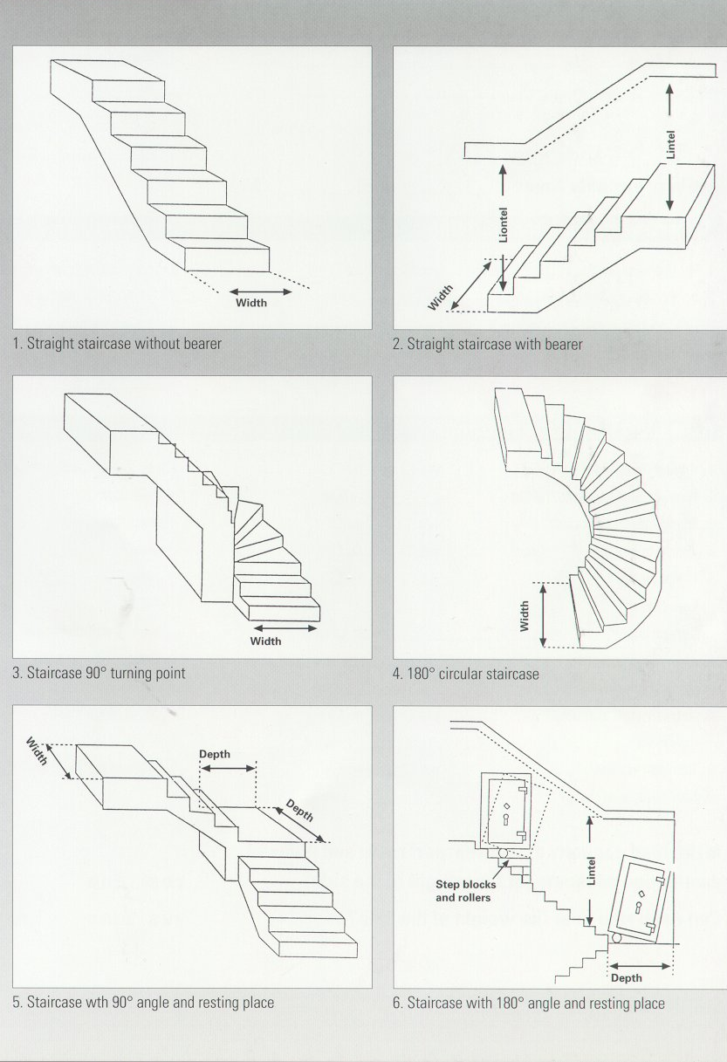

5a) Total no. of stairs_______________________________________________________
5b) Type of staircase? See above No._______________________________________
5c) Type of construction, please state (wooden, concrete etc) ____________________
- Staircase dimensions :
a) Lintel Height____________________b) Width of Staircase_______________________
c) Width of resting place____________d) Depth of resting place____________________
7) Can each step bear the weight of the safe? YES NO
8) Is the load capacity of the transport route and place of destination adequate for the weight of the safe? YES NO
*Details completed by CIA - Name ____________________Date _________
*Details completed by Customer – Name____________________________
Date ______________________ Signed _________________________________________
* Delete as applicable Page 2 of 2

