Control Equipment Limited
Precept ^{en} Fire Detection/Alarm Panel and Precept ^{en} Repeater
User Operation Manual

List Of Contents
1. List Of Contents 2
2. Precept ^{en} User Operation - Fire and Fault Conditions 4
2.1. If a fire is detected: 4
2.2. To Silence the fire alarm sounders: 4
2.3. To Resound the fire alarm sounders after they have been silenced: 4
2.4. To Reset the panel from a Fire Alarm: 4
2.5. To operate the fire alarm sounders in Evacuate Mode: 5
2.6. If a fault is detected: 5
2.7. To Silence the Buzzer: 5
3. Precept ^{en} User Indications 6
4. Precept ^{en} User Controls 7
5. Precept ^{en} User Controls – Disablement and Test Conditions. 8
5.1. To Disable/Enable any Zone or Zones. 8
5.2. To Disable/Enable all Sounders. 8
5.3. To Disable/Enable the Fire Routing Output. 9
5.4. To Disable/Enable the Fault Routing Output. 9
5.5. To Disable/Enable Fire Protection Output[s]. 10
5.6. To Select/Clear One Man Zone Test. 11
5.7. To Select/Clear One Man Sounder Test. 11
5.8. To Enable/Disable Delay Mode 12
5.9. To Override the Delay Mode 12
5.10. To Extend the Delay [from 1st stage to 2nd Stage] 13
5.11. Silencing the Alarms During the Delay: 13
5.12. Resounding the Alarms after the Delay: [Alarms previously silenced] 13
6. Precept ^{en} Repeater Panel User Operation - Fire and Fault Conditions 14
6.1. If a fire is detected: 14
6.2. To Silence the fire alarm sounders: 14
6.3. To Resound the fire alarm sounders after they have been silenced: 14
6.4. To Reset the panel & repeater(s) from a Fire Alarm: 14
6.5. To operate the fire alarm sounders in Evacuate Mode: 15
6.6. If a fault is detected: 15
6.7. To Silence the Buzzer: 15
Precept ^{en} Repeater Panel Operation [16 zone version shown] 16
7. Precept en Repeater Panel User Controls [16 zone panel shown] 17
8. Routine Testing and maintenance 17
9. User responsibilities 17
10. Precept en Isolate/De-isolate/Test Mode Select Flowchart 18

Danger
This equipment contains hazardous voltages that can cause death, serious personal injury, or equipment damage.
This equipment contains no user serviceable parts. Refer all maintenance to suitably qualified personnel.

Precept ^{en} User Operation - Fire and Fault Conditions

If a fire is detected:
- On the Precept ^{en} Fire Alarm Panel:
- The general Fire LED will flash and the buzzer will sound
- The relevant zone Fire LED will flash, indicating the location of the fire.
- If the Delay is OFF [Delay LED off]:
  - The Fire Routing output and LED will operate immediately
  - The Fire Alarm sounders will operate immediately
  - The Fire Protection output will operate immediately
- If the Delay is ON [Delay LED flashing]:
  - The Fire Routing output and LED will operate after a delay [if the Fire Routing fault/disabled LED is illuminated].
  - The Fire Alarm sounders will operate after a delay [if Sounder fault/disabled LED is illuminated].
  - The Fire Protection output will operate after a delay [if Fire Protection fault/disabled LED is illuminated].
- Locate the source of the fire alarm (an LED will be visible on the detector which has been activated).

To Silence the fire alarm sounders:
- Turn the Access Controls Keyswitch on the panel door to position “1”.
- Press the Silence Alarms/Resound button once only.
- The fire alarm sounders will become silent.
- The General Fire LED and the Zone Fire LED will become steady.
- Set the Access Controls Keyswitch back to position “0” to lock the controls.

To Resound the fire alarm sounders after they have been silenced:
- Turn the Access Controls Keyswitch on the panel door to position “1”.
- Press the Silence Alarms/Resound button once only.
- Set the Access Controls Keyswitch back to position “0” to lock the controls.

To Reset the panel from a Fire Alarm:
- After the fire has been extinguished, turn the Access Controls Keyswitch on the panel door to position “1”.
- Press the Reset button.
- The General Fire LED and the Zone Fire LED will clear.
- Set the Access Controls Keyswitch back to position “0” to lock the controls.

To operate the fire alarm sounders in Evacuate Mode:
- Turn the Access Controls Keyswitch on the panel door to position “1”.
- Press the Evacuate button.
- The Evacuate LED will light and the panel buzzer will operate.
- All fire alarm sounders will operate.
- Press the Silence/Resound Alarm button to silence the fire alarm sounders and clear the Evacuate LED.
- Set the Access Controls Keyswitch back to position “0” to lock the controls.

If a fault is detected:
- The panel buzzer will sound.
- The General Fault LED will flash.
- One or more fault LEDs will flash; identifying which element of the system is faulty.
- When the fault is corrected the fault indication will clear automatically unless the panel is configured to latched fault mode – in which case, operating the Reset button will clear the fault indication.

To Silence the Buzzer:
- Press the Silence Buzzer button.
- The Silence Buzzer button LED will light.
- The buzzer will silence.

Precept ^{en} User Indications
General Indicator Section
Indicator Description | Indication Colour | Operating Condition
Power Supply On | Green | Steady indication for Mains or Standby power On.
Fire | Red | Flashes on any new fire alarm condition, changing to a steady indication on operation of Silence Alarms.
Fire Routing Active | Red | Steady indication when the Fire Routing Output is active.
General Fault | Yellow | Flashes for any fault condition.
Power Supply Fault | Yellow | Flashes for mains or standby power supply/charge fault
System Fault | Yellow | Steady indication to indicate Microcontroller or Memory Failure.  Flashes to indicate Engineer’s Configuration Mode active.
Earth Fault | Yellow | Flashes for any positive or negative power supply earth fault.
Fuse Fault | Yellow | Flashes for any auxiliary supply fuse failure
Repeater Fault | Yellow | Flashes for any Repeater fault or repeater communication fault,
Sounder Fault/Disabled | Yellow | Flashes for any sounder fault. Steady for sounders disabled.
Sounder Test | Yellow | Steady indication while sounder walk test is active.
Fire Protection Fault/Disabled | Yellow | Flashes for a fault on the Fire Protection Output. Steady when Fire Protection Output is disabled.
Fire Routing Fault/Disabled | Yellow | Flashes for a fault on the Fire Routing Output. Steady when Fire Routing Output is disabled.
Fault Routing Fault/Disabled | Yellow | Flashes for a fault on the Fault Routing Output. Steady when Fault Routing Output is disabled.
Access Controls Keyswitch:
0 – Controls Locked
1 – Controls Unlocked
User Instructions
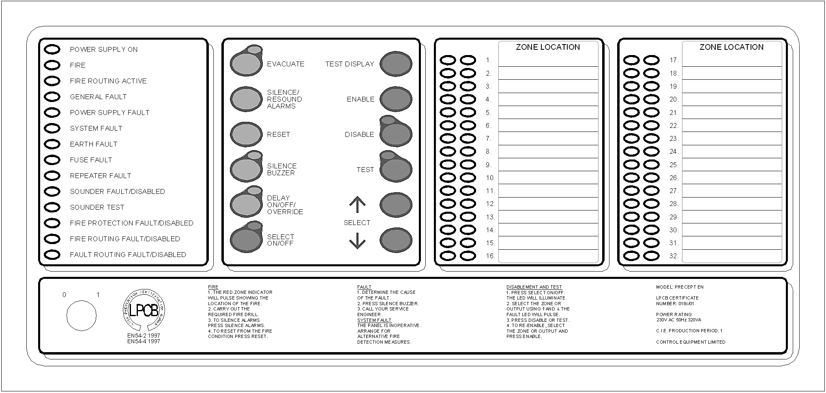

Zone Location Indications
Indicator Description | Indication Colour | Operating Condition
User Generated Zone Location Text | Red | Flashes when zone is in a fire condition, turning to steady on operation of Silence Alarms.
User Generated Zone Location Text | Yellow | Flashes when zone is in a fault condition. Illuminates steady when zone is disabled or in test.

Precept ^{en} User Controls

Access Controls Keyswitch:
0 – Controls Locked
1 – Controls Unlocked

Switch Description | Functionality | Button Availability
Evacuate | Operates all sounders continuously and lights the Evacuated LED adjacent the button until the silence button is operated | When controls are unlocked
Silence/Resound Alarms | Following a fire alarm condition, 1st operation stops sounders. The General Fire LED and the Zonal fire LED will change from flashing to steady. 2nd operation restarts the previously silenced sounders | When controls are unlocked
Reset | Clears the panel display, resets the zones, outputs and operates the reset relay. | When controls are unlocked  and [if silence before reset is configured] alarms silence switch has been operated.
Silence Buzzer | 1] Press to stop the buzzer sounding in fire or fault conditions. | When controls are locked or unlocked
Silence Buzzer | 2] In 2 Stage Delay Mode, with stage 1 delay running, press to start stage 2 delay otherwise all delayed outputs operate when Stage 1 timer times out. | When the panel is in the fire condition and the delay is running. Controls are locked or unlocked
Delay On/Off/Override | 1] Press once to Enable the delay mode, lighting the adjacent delay on LED. Press again to disable the delay mode and turn off the LED | 1] When controls are unlocked and delay period is set to a value > 0.
Delay On/Off/Override | 2] Overrides the delay when delay is running, turning the delay mode and the LED off. All delayed outputs will operate immediately. | 2] When the panel is in the fire condition and the delay is running.
Select On/Off | Enables the User select feature for selection of zones or outputs via Select ↑ Select ↓ for disablement/re-enablement | When controls are unlocked
Test Display | Press to illuminates all LEDs on the display and operate the buzzer. All indications remain active for approx 5 seconds after button release. | When controls are locked or unlocked
Enable | Press to clear the disablement or test condition on a zone or output selected via the User Select feature. | When controls are unlocked, the Select switch has been operated and a zone or output has been selected.
Disable | Press to disable a zone or output selected via the User Select feature. | As above.
Test | Press to initiate the One Man Test on sounders or zones as selected via the User Select feature. | As above.
Select ↑ Select ↓ | Used to scroll the cursor indication through the zone and output fault LEDs on the display to select a zone or output for disablement, or test. [LED illuminated when Select Mode is active] | When controls are unlocked and the Select switch has been operated.

Precept ^{en} User Controls – Disablement and Test Conditions.

To Disable/Enable any Zone or Zones.
- To Access disable/enable mode:
- Turn the Access Controls Keyswitch on the panel door to position “1”.
- Press the Select On/Off button to enter the Select Mode:
- The Select On LED will light.
- The cursor indication will pulse the yellow Zone 1 fault/disabled/test LED.
- To select the zone:
- Use the Select ↓ button to move the pulsed cursor indication down through the fault LEDs until it pulses the required zone. [The Select ↑ button moves the cursor up].
- To disable the selected zone:
- Press the Disable button to disable the selected zone.
- The zone fault/disabled LED will change to the “On-flash” indication while the cursor is on it, changing to steady if the cursor is moved on.
- The general Disablement LED will light.
- To enable the selected zone:
- Press the Enable button to enable the selected zone.
- The zone fault/disabled LED will change to the “Off-flash” indication while the cursor is on it, changing to off if the cursor is moved on.
- The general Disablement LED will be cleared if no other disablements are present.
- To quit the disable/enable mode:
- To exit the Select Mode, press the Select On/Off button.
- The Select On LED will clear.
- The cursor indication will clear.
- Set the Access Controls Keyswitch back to position “0” to lock the controls.

To Disable/Enable all Sounders.
- To Access disable/enable mode:
- Turn the Access Controls Keyswitch on the panel door to position “1”.
- Press the Select On/Off button to enter the Select Mode:
- The Select On LED will light.
- The cursor indication will pulse the yellow Zone 1 fault/disabled/test LED.
- To select the sounders:
- Use the Select ↑ button to move the pulsed cursor indication up through the fault LEDs until it pulses the Sounder Fault/Disabled and Sounder Test LEDs. [The Select ↓ button moves the cursor down].
- To disable the sounders:
- Press the Disable button to disable the sounders.
- The Sounder Fault/Disabled LED will change to the “On-flash” indication while the cursor is on it, changing to steady if the cursor is moved.
- The general Disablement LED will light.
- To enable the sounders:
- Press the Enable button to enable the sounders.
- The Sounder Fault/Disabled LED will change to the “Off-flash” indication while the cursor is on it, changing to off if the cursor is moved on.
- The general Disablement LED will be cleared if no other disablements are present.
- To quit the disable/enable mode:
- To exit the Select Mode, press the Select On/Off button.
- The Select On LED will clear.
- The cursor indication will clear.
- Set the Access Controls Keyswitch back to position “0” to lock the controls.

To Disable/Enable the Fire Routing Output.
- To Access disable/enable mode:
- Turn the Access Controls Keyswitch on the panel door to position “1”.
- Press the Select On/Off button to enter the Select Mode:
- The Select On LED will light.
- The cursor indication will pulse the yellow Zone 1 fault/disabled/test LED.
- To select the Fire Routing Output:
- Use the Select ↑ button to move the pulsed cursor indication up through the fault LEDs until it pulses the Fire Routing Fault/Disabled LED. [The Select ↓ button moves the cursor down].
- To disable the Fire Routing Output:
- Press the Disable button to disable the Fire Routing Output.
- The Fire Routing Fault/Disabled LED will change to the “On-flash” indication while the cursor is on it, changing to steady if the cursor is moved.
- The general Disablement LED will light.
- To enable the Fire Routing Output:
- Press the Enable button to enable the Fire Routing Output.
- The Fire Routing Fault/Disabled LED will change to the “Off-flash” indication while the cursor is on it, changing to off if the cursor is moved on.
- The general Disablement LED will be cleared if no other disablements are present.
- To quit the disable/enable mode:
- To exit the Select Mode, press the Select On/Off button.
- The Select On LED will clear.
- The cursor indication will clear.
- Set the Access Controls Keyswitch back to position “0” to lock the controls.

To Disable/Enable the Fault Routing Output.
- To Access disable/enable mode:
- Turn the Access Controls Keyswitch on the panel door to position “1”.
- Press the Select On/Off button to enter the Select Mode:
- The Select On LED will light.
- The cursor indication will pulse the yellow Zone 1 fault/disabled/test LED.
- To select the Fault Routing Output:
- Use the Select ↑ button to move the pulsed cursor indication up through the fault LEDs until it pulses the Fault Routing Fault/Disabled LED. [The Select ↓ button moves the cursor down].
- To disable the Fault Routing Output:
- Press the Disable button to disable the Fault Routing Output.
- The Fault Routing Fault/Disabled LED will change to the “On-flash” indication while the cursor is on it, changing to steady if the cursor is moved.
- The general Disablement LED will light.
- To enable the Fault Routing Output:
- Press the Enable button to enable the Fault Routing Output.
- The Fault Routing Fault/Disabled LED will change to the “Off-flash” indication while the cursor is on it, changing to off if the cursor is moved on.
- The general Disablement LED will be cleared if no other disablements are present.
- To quit the disable/enable mode:
- To exit the Select Mode, press the Select On/Off button.
- The Select On LED will clear.
- The cursor indication will clear.
- Set the Access Controls Keyswitch back to position “0” to lock the controls.

To Disable/Enable Fire Protection Output[s].
- To Access disable/enable mode:
- Turn the Access Controls Keyswitch on the panel door to position “1”.
- Press the Select On/Off button to enter the Select Mode:
- The Select On LED will light.
- The cursor indication will pulse the yellow Zone 1 fault/disabled/test LED.
- To select the Fire Protection Output:
- Use the Select ↑ button to move the pulsed cursor indication up through the fault LEDs until it pulses the Fire Protection Fault/Disabled LED. [The Select ↓ button moves the cursor down].
- To disable the Fire Protection Output:
- Press the Disable button to disable the Fire Protection Output.
- The Fire Protection Fault/Disabled LED will change to the “On-flash” indication while the cursor is on it, changing to steady if the cursor is moved.
- The general Disablement LED will light.
- To enable the Fire Protection Output:
- Press the Enable button to enable the Fire Protection Output.
- The Fire Protection Fault/Disabled LED will change to the “Off-flash” indication while the cursor is on it, changing to off if the cursor is moved on.
- The general Disablement LED will be cleared if no other disablements are present.
- To quit the disable/enable mode:
- To exit the Select Mode, press the Select On/Off button.
- The Select On LED will clear.
- The cursor indication will clear.
- Set the Access Controls Keyswitch back to position “0” to lock the controls.

To Select/Clear One Man Zone Test.
- To access test selection mode:
- Turn the Access Controls Keyswitch on the panel door to position “1”.
- Press the Select On/Off button to enter the Select Mode:
- The Select On LED will light.
- The cursor indication will pulse the yellow Zone 1 fault/disabled/test LED.
- To select the zone to be tested:
- Use the Select ↓ button to move the pulsed cursor indication down through the fault LEDs until it pulses on the required zone. [The Select ↑ button moves the cursor up].
- To apply the test mode to the selected zone:
- Press the Test button to activate the test condition on the selected zone.
- The zone fault/disabled LED will change to the “On-flash” indication while the cursor is on it, changing to steady if the cursor is moved on.
- The general Test LED will light.
- To clear the test mode on the selected zone:
- Press the Test button again or press the Enable button to clear the test condition enabling normal operation of the selected zone.
- The zone fault/disabled LED will change to the “Off-flash” indication while the cursor is on it, changing to off if the cursor is moved on.
- The general Test LED will be cleared if no other circuits are in the test condition.
- To quit the zone test selection mode:
- To exit the Select Mode, press the Select On/Off button.
- The Select On LED will clear.
- The cursor indication will clear.
- Set the Access Controls Keyswitch back to position “0” to lock the controls.

To Select/Clear One Man Sounder Test.
- To access test selection mode:
- Turn the Access Controls Keyswitch on the panel door to position “1”.
- Press the Select On/Off button to enter the Select Mode:
- The Select On LED will light.
- The cursor indication will pulse the yellow Zone 1 fault/disabled/test LED.
- To select the sounders:
- Use the Select ↑ button to move the pulsed cursor indication up through the fault LEDs until it pulses the Sounder Fault/Disabled and Sounder Test LEDs. [The Select ↓ button moves the cursor down].
- To activate the sounder test:
- Press the Test button to start the sounder test.
- The Sounder Test LED will change to the “On-flash” indication while the cursor is on it, changing to steady if the cursor is moved.
- The general Test LED will light.
- The sounders will operate for 2 seconds every 15 seconds until the test mode is switched off.
- To terminate the sounder test:
- Press the Test button again or press the Enable button to clear the test condition enabling normal operation of sounders.
- The sounders will silence.
- The Sounder Test LED will change to the “Off-flash” indication while the cursor is on it, changing to off if the cursor is moved on.
- The general Test LED will be cleared if no other circuits are in the test condition.
- To quit test selection mode:
- To exit the Select Mode, press the Select On/Off button.
- The Select On LED will clear.
- The cursor indication will clear.
- Set the Access Controls Keyswitch back to position “0” to lock the controls.

To Enable/Disable Delay Mode
- To access delay mode selection:
- Turn the Access Controls Keyswitch on the panel door to position “1”.
- To enable the delay:
- Press the Delay On/Off/Override button once to enable the Delay Mode.
- The Delay On/Off LED will light.
- The disable switch LED will light.
- The fault/disabled LED for each delayed output will light.
- To disable the delay:
- With the Delay On, press the Delay On/Off/Override button once to disable the Delay Mode.
- The Delay On/Off LED will clear.
- The disable switch LED will clear.
- The fault/disabled LED for each delayed output will clear.
- To quit delay mode selection:
- Set the Access Controls Keyswitch back to position “0” to lock the controls.

To Override the Delay Mode
- When the Delay is running:
- The Delay On/Off LED will flash.
- The general Fire and zone fire LEDs will flash.
- The panel buzzer will operate.
- Press the Delay On/Off/Override button while the Delay On/Off LED is flashing to override the delay allowing all delayed outputs to operate immediately.

To Extend the Delay [from 1st stage to 2nd Stage]
- When the panel is configured to the two stage delay mode and before 60 seconds has elapsed since the fire alarm triggered:
- Press the Silence Buzzer button.
- The Silence Buzzer button LED will light.
  - The buzzer will silence.
  - The 2nd stage delay will start.

Silencing the Alarms During the Delay:
- Turn the Access Controls Keyswitch on the panel door to position “1”.
- Press the Silence Alarms/Resound button.
- The General Fire LED and the Zone Fire LED become steady.
- The sounders will not operate after the delay has timed out.
- Set the Access Controls Keyswitch back to position “0” to lock the controls.

Resounding the Alarms after the Delay: [Alarms previously silenced]
- Turn the Access Controls Keyswitch on the panel door to position “1”.
- Press the Silence Alarms/Resound button.
- The General Fire LED will flash.
- The sounders operate.
- Set the Access Controls Keyswitch back to position “0” to lock the controls.

Precept ^{en} Repeater Panel User Operation - Fire and Fault Conditions

If a fire is detected:
- On the Precept ^{en} Repeater Panel:
- The general Fire LED will flash and the buzzer will sound
- The relevant zone Fire LED will flash, indicating the location of the fire.
- If the Delay is OFF [Delay LED off]:
  - The Fire Routing output and LED will operate immediately
  - The Fire Alarm sounders will operate immediately
  - The Fire Protection output will operate immediately
- If the Delay is ON [Delay LED flashing]:
  - The Fire Routing output and LED will operate after a delay [if the Fire Routing fault/disabled LED is illuminated].
  - The Fire Alarm sounders will operate after a delay [if Sounder fault/disabled LED is illuminated].
  - The Fire Protection output will operate after a delay [if Fire Protection fault/disabled LED is illuminated].
- Locate the source of the fire alarm (an LED will be visible on the detector which has been activated).

To Silence the fire alarm sounders:
- Turn the Access Controls Keyswitch on the repeater door to position “1”.
- Press the Silence Alarms/Resound button once only.
- The fire alarm sounders will become silent.
- The General Fire LED and the Zone Fire LED will become steady.
- Set the Access Controls Keyswitch back to position “0” to lock the controls.

To Resound the fire alarm sounders after they have been silenced:
- Turn the Access Controls Keyswitch on the repeater door to position “1”.
- Press the Silence Alarms/Resound button once only.
- Set the Access Controls Keyswitch back to position “0” to lock the controls.

To Reset the panel & repeater(s) from a Fire Alarm:
- After the fire has been extinguished, turn the Access Controls Keyswitch on the repeater door to position “1”.
- Press the Reset button.
- The General Fire LED and the Zone Fire LED will clear.
- Set the Access Controls Keyswitch back to position “0” to lock the controls.

To operate the fire alarm sounders in Evacuate Mode:
- Turn the Access Controls Keyswitch on the repeater door to position “1”.
- Press the Evacuate button.
- The Evacuate LED will light and the repeater buzzer will operate.
- All fire alarm sounders will operate.
- Press the Silence/Resound Alarm button to silence the fire alarm sounders and clear the Evacuate LED.
- Set the Access Controls Keyswitch back to position “0” to lock the controls.

If a fault is detected:
- The repeater buzzer will sound.
- The General Fault LED will flash.
- One or more fault LEDs will flash; identifying which element of the system is faulty.
- When the fault is corrected the fault indication will clear automatically unless the panel is configured to latched fault mode – in which case, operating the Reset button will clear the fault indication.

To Silence the Buzzer:
- Press the Silence Buzzer button.
- The Silence Buzzer button LED will light.
- The buzzer will silence.

Precept ^{en} Repeater Panel Operation [16 zone version shown]
General Indicator Section
Indicator Description | Indication Colour | Operating Condition
Power Supply On | Green | Steady indication for Mains or Standby power On.
Fire | Red | Flashes on any new fire alarm condition, changing to a steady indication on operation of Silence Alarms.
Fire Routing Active | Red | Steady indication when the Fire Routing Output is active.
General Fault | Yellow | Flashes for any fault condition.
Power Supply Fault | Yellow | Flashes for mains or standby power supply/charge fault
System Fault | Yellow | Steady indication to indicate Microcontroller Failure.
General Test | Yellow | Steady indication when the zone or sounder test is active.
General Disablement | Yellow | Steady indication whilst a zone or output is disabled.
Communications Fault | Yellow | Flashes for a communications failure between the fire panel and repeater.
Sounder Fault/Disabled | Yellow | Flashes for any sounder fault. Steady for sounders disabled.
Sounder Test | Yellow | Steady indication while sounder walk test is active.
Fire Protection Fault/Disabled | Yellow | Flashes for a fault on the Fire Protection Output. Steady when Fire Protection Output is disabled.
Fire Routing Fault/Disabled | Yellow | Flashes for a fault on the Fire Routing Output. Steady when Fire Routing Output is disabled.
Fault Routing Fault/Disabled | Yellow | Flashes for a fault on the Fault Routing Output. Steady when Fault Routing Output is disabled.

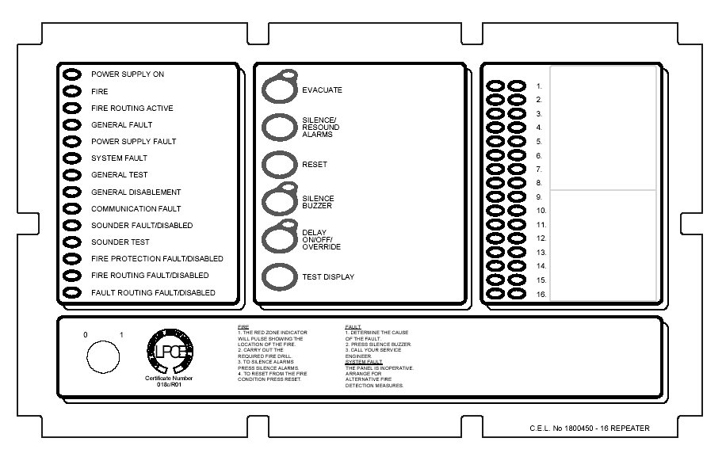
Access Controls Keyswitch:
0 – Controls Locked
1 – Controls Unlocked
User Instructions

Zone Location Indications
Indicator Description | Indication Colour | Operating Condition
User Generated Zone Location Text | Red | Flashes when zone is in a fire condition, turning to steady on operation of Silence Alarms.
User Generated Zone Location Text | Yellow | Flashes when zone is in a fault condition. Illuminates steady when zone is disabled or in test.

Precept en Repeater Panel User Controls [16 zone panel shown]
Access Controls Keyswitch:
0 – Controls Locked
1 – Controls Unlocked

Switch Description | Functionality | Button Availability
Evacuate | Operates all sounders continuously and lights the Evacuated LED adjacent the button until the silence button is operated | When controls are unlocked
Silence/Resound Alarms | Following a fire alarm condition, 1st operation stops sounders. The General Fire LED and the Zonal fire LED will change from flashing to steady. 2nd operation restarts the previously silenced sounders | When controls are unlocked
Reset | Clears the panel display, resets the zones, outputs and operates the reset relay. | When controls are unlocked  and [if silence before reset is configured] alarms silence switch has been operated.
Silence Buzzer | 1] Press to stop the buzzer sounding in fire or fault conditions. | When controls are locked or unlocked
Silence Buzzer | 2] In 2 Stage Delay Mode, with stage 1 delay running, press to start stage 2 delay otherwise all delayed outputs operate when Stage 1 timer times out. | When the panel is in the fire condition and the delay is running. Controls are locked or unlocked
Delay On/Off/Override | 1] Press once to Enable the delay mode, lighting the adjacent delay on LED. Press again to disable the delay mode and turn off the LED | 1] When controls are unlocked and delay period is set to a value > 0.
Delay On/Off/Override | 2] Overrides the delay when delay is running, turning the delay mode and the LED off. All delayed outputs will operate immediately. | 2] When the panel is in the fire condition and the delay is running.
Test Display | Press to illuminates all LEDs on the display and operate the buzzer. All indications remain active for approx 5 seconds after button release. | When controls are locked or unlocked

Routine Testing and maintenance
See Precept en Log Book for details.

User responsibilities
See Precept en Log Book for details

Precept en Isolate/De-isolate/Test Mode Select Flowchart


